TIMELINE FOR THE Virtual Lab Meeting Mentoring Program
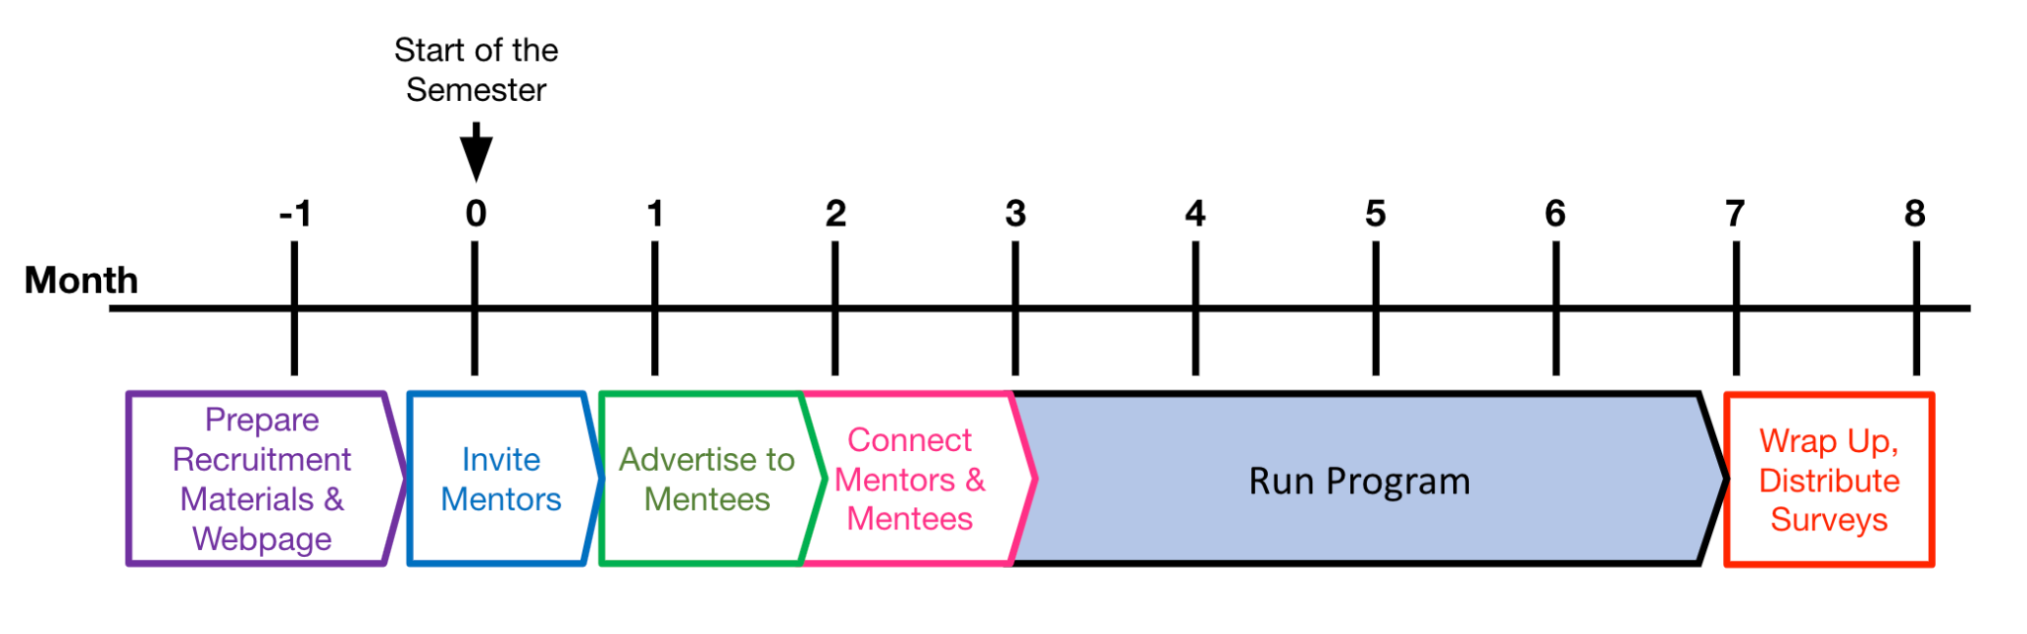

~July 1 Formation of this year’s Committee

Person | Email | Role

~August 1 - Update the webpage
- Person in charge:
- Example page: https://rcn-ecs.github.io/2021virtuallabcall/

~August 15 - Prepare the forms
- Person in charge:
- Form for mentor signup
- Form for mentee signup
- Prepare “Expectations for Mentors”

~End Aug - Sept 1 - Send an email to mentors
- Person in charge of communications:

Email template to send to mentors (edit fields in pink):

The Research Coordinated Network for Evolution in Changing Seas is excited to announce the third year of our Virtual Lab Meeting Training Program.

In this program, we seek to provide training to students at the undergraduate or graduate level (“mentees”) by matching them to a research group that shares their interests. The mentee will participate by attending lab meetings during 202X-202X. A designated mentor from the research group will dedicate portions of two lab meetings to the mentee’s professional development. The format for lab meetings dedicated to the mentee’s professional development is flexible, but could take the form of review of graduate school or grant application statements at lab meeting, research presentation at lab meeting, lead paper discussion at lab meeting, etc.

Mentors may be Faculty, Postdoctoral Fellows, or Research Associates - as long as lab meetings can be dedicated to the mentees professional development. A survey from last year indicated that this program takes less than 3 extra hours of a mentor’s time (outside lab meetings) over the course of an academic year, while providing important professional development for the mentee.

For more information:

ENTER LINK

If you are a faculty, postdoc, or research scientist, please sign up to be a host-mentor by Sept 15 at this form: ENTER LINK. When you fill out the form, please enter the regular time of your weekly lab meetings. This will help us ensure mentees that choose you as a mentor can make that time.

If you know a graduate student or undergraduate who would benefit from this program, please tell them to apply to be a mentee between Sept 15 and Sept 30. They will be able to choose their preferred mentors from those who register and the RCN will match mentors and mentees. We would greatly appreciate it if you encouraged students from underrepresented groups in our fields to apply.

Warm regards,

COMMITTEE MEMBERS

~Sept 10 - Send a reminder email to mentors
- Evaluate if you are going to have ~30-40 mentors. In the past we’ve had about 30-40 mentees sign up, but that was with the stipend.
- Send another round of reminder emails to all the lists above
~Sept 14- Extend deadline if needed
- Budget an extra week to ~Sept 21 to extend the deadline for mentors if needed

~ Sept 21-Oct 7
- Advertise to mentees
- Send email to previous mentors encouraging them to share with their labs:
- Send emails to diversity lists
- Send email to RCN-ECS listserv
- Send email to previous mentees

Example email to solicit students:
The Research Coordinated Network for Evolution in Changing Seas is excited to announce the third year of our Virtual Lab Meeting Training Program. This is a great opportunity for students broadly interested in evolution, biology, or marine science to advance their career over the course of the academic year while at their home institution. We welcome undergraduate students or graduate students from all backgrounds to apply. We would greatly appreciate it if you would share this announcement with eligible students!

In this program, we seek to provide training to students at the undergraduate or graduate level (“mentees”) matching them to an academic research group that shares their interests. The mentee will participate by attending lab meetings virtually during 2021-2022. During lab meetings, the mentee will learn about the lab’s research and make professional connections with other students in the lab. Participating labs work with many different species and in all kinds of different places around the world.

A designated Mentor from the research group will dedicate portions of two lab meetings to the mentee’s professional development. The format for lab meetings dedicated to the mentee’s professional development is flexible, but could take the form of a professional development discussion about what graduate school is like, feedback on graduate school or grant application statements, a practice presentation, or a paper discussion. Survey data indicate that this program is successful at improving the professional network of mentees and creating new opportunities for them, while also bringing their unique perspective to the research labs.

Undergraduate or graduate students who are interested in being a mentee with the program can sign up here between September 15 and Sept 30:

<WEBSITE>

Warm regards,

LIST COMMITTEE

~ Oct 7-Oct 15 Place mentees to a lab
- People in charge (2-3 people):
- We usually assign mentors to mentees in the order that the mentee applied, so earlier applicants typically get their first or second choice.
- Katie has a formula for helping with this for the Mentee Google sheet. The formula highlights mentors with a red color who have already been assigned to a mentee. Note this doesn’t work perfectly if applicant’s don’t spell the Mentor’s name correctly.

How to Apply the Custom Formula:
- Copy the Mentor table into a new tab in the Mentee Sheet
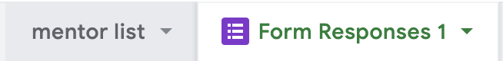

2. Add the following columns to the very right side of the Mentee Form Responses

3. When you pick a mentor for that person, you will put the mentor’s name under “Assignment”. To get their email to automatically populate, use the custom formula
=index('mentor list'!$B$2:$B$33,match(AF2,'mentor list'!$A$2:$A$33,0),1)
'mentor list'!$B$2:$B$33 is the list of emails in the mentor list tab
AF2 is the “Assignment” column and row
'mentor list'!$A$2:$A$33 is the list of names in the mentor list tab

4. Highlight the entire block of cells for “First choice” to “Forth choice” Mentor (all rows) and go to Format: Conditional Formatting

5. Make sure the entire block of cells for “First choice” to “Forth choice” Mentor (all rows) is correct under “Apply to range” of cells (see image below)
  - Add the following custom formula
=countif($AF$2:$AF$50,Q2)>0
- The formula asks if the mentor’s name is used at least once in the “Assignments” column and if so, it highlights the cell red
- $AF$2:$AF$50 are the list of Mentor’s names in the “Assignments” column
- Q2 is the cell that is in the upper left hand corner of the entire block of cells for “First choice” to “Forth choice” Mentor (see last image)

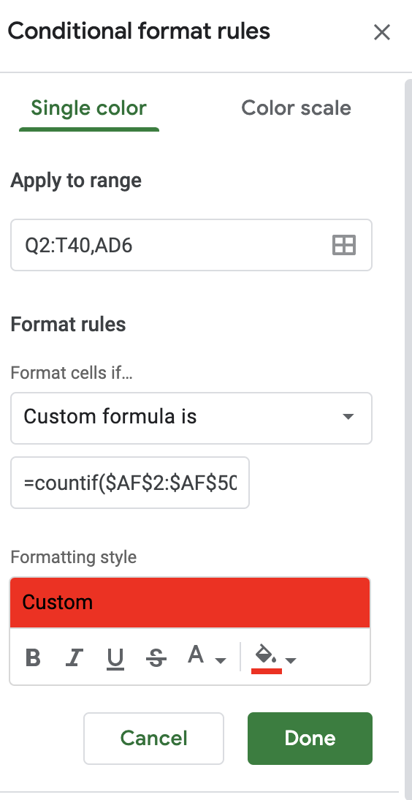

~ Oct 15: Send individual emails to mentee/mentor pairs
- Same people who place mentees should send this email
- Provide mentees with a contact person
- Email template with formula to put in the spreadsheet (change the pink cells to be the correct cells for the mentee and mentor) :

="Dear "&C2&",
Thank you for signing up for the Evolving Seas RCN Virtual Lab Meeting Training Program. We are excited to place you with "&AF2&" (cc'd). Please touch base with your mentor about their lab meeting time. If the placement doesn’t work out for some reason, don’t hesitate to contact us so that we may find a better placement.

To complete the program you must attend 10 lab meetings, with portions of 2 lab meetings dedicated to your professional development) before May 202X. The lab meetings that are devoted to your professional development could take many different forms, such as leading a paper discussion, or getting feedback on a draft of an assignment, application, or manuscript.

Best,
COMMITTEE

~ Nov 15- Dec 1: Check in with mentee/mentor pairs
- Person in charge:

~ Jan 15: Check in with mentee/mentor pairs for the new semester
- Person in charge:
- Invite them to participate in other events

~ May 15: Completion and survey

